11th International Scientific Conference
“Analytical Mechanics, Stability and Control”

CALL FOR PAPERS

Kazan National Research Technical University named after А.N. Tupolev (KNRTU-KAI) with participation of leading academic institutions and universities of Russia holds the 11th International Scientific Conference on Analytical Mechanics, Stability and Control on June 14-18, 2017 in Kazan (Russia).
Like all of the preceding conferences, this conference is called Chetaev in honor of the eminent mechanician and mathematician Nikolai Guryevich Chetaev. Previous conferences were held in 1962, 1973, 1987, 1992, 1997, 2002, and 2012 in Kazan, housed by KAI (since 2009 – KNRTU-KAI), in 1982 – in Moscow (Zvenigorod), housed by Computing Centre of the Academy of Sciences USSR, in 1977 and 2007 – in Irkutsk (Lake Baikal) housed by IDSTU SB RAS.

The Conference is supported by
- The Ministry of Education and Science of the Russian Federation,
- The Russian Academy of Sciences (RAS),
- Russian Foundation for Fundamental Research
- The Ministry of Education and Science of the Republic of Tatarstan,
- Tatarstan Academy of Sciences,
- Russian National Committee on Theoretical and Applied Mechanics,
- Russian National Committee on Automatic Control,
- Scientific Council on the Theory of Controlled Processes and Automation.

The work of the Conference is planned in the form of plenary and oral sessions, as well as discussions on the following topics:
- Analytical mechanics
- Stability
- Control
- Computer technologies in education, production management, and simulators
The Young Scientists School on analytical mechanics and control will be held within the scope of the conference.

International Program Committee
Co-Chairmen: S.N. Vassyliev, V.V. Kozlov
Vice-chairman: G.L. Degtyarev
The Conference Secretariat: A.Y. Hasanov, P.A. Lazareva, I.V. Petruv
Contacts:
Polina Lazareva, E-mail: PALazareva@kai.ru
Phone, Fax: +7 (843) 231 03 37.

Official languages: English and Russian.

Important dates: to attend the conference the following documents should be sent to the Organizing Committee:

- December 30th, 2016 – application form (email with the subject “Application form”);
- January 30th, 2017 – submission of papers of 5 up to 10 pages (email with the subject “The paper”.

Notification of acceptance will be sent by April 1st, 2017.

Venue

The conference will be held in Kazan - the city with millenial history, well-known scientific, educational, industrial, cultural center.

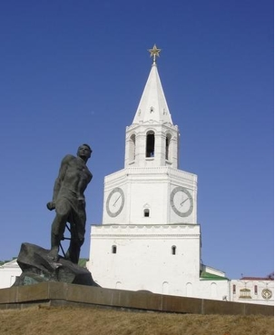

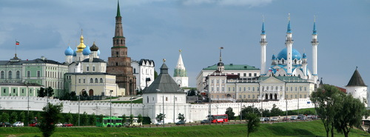
Social Program

- A day trip to the great Russian river Volga with a visit to the island Sviyazhsk.
- A sight-seeing tour with a visit to the Kazan Kremlin and museums are planned.

Conference Fees

The registration fee for participants from Russia and other countries of CIS is 2000 rubles, for graduate and undergraduate students from these countries – 1000 rubles, for foreign participants – 100 USD. Foreign participants pay the registration fee on arrival at the conference.

Upon registration, each participant from Russia and other CIS countries must pay an additional registration fee of 500 rubles, international participants – 100 USD (payment for local transportation and other organizational costs, including social program, official reception, coffee-breaks expenses). This registration fee for graduate and undergraduate students from the CIS is 250 rubles, for foreign graduate and undergraduate students – 50 USD.

One-day tour on the Volga River is charged separately. Detailed information about this, as well as on the housing conditions and costs will be announced in the next announcement.

